ANALYSIS REPORT OF

WALMART STOCK DATA 2024

### INTRODUCTION

Walmart, also known as Wal-Mart Stores, Inc., is an American multinational retail corporation that operates a chain of hypermarkets, discount department stores, and grocery stores .As of October 2024 Walmart has a market cap of $645.39 Billion USD. This makes Walmart the world's 13th most valuable company by market cap according to our data.

### OBJECTIVE

### Data Collection:

By acquiring a well-structured dataset. This dataset included details such as customer information, booking dates, room types, cancellations, and more. The data was stored in a relational database.

* **Data Cleaning and Pre-processing:**

Performed data cleaning tasks to handle missing values, duplicate records, and outliers, ensuring the datasets integrity.

* **SQL Queries:**

Designed and executed SQL queries to extract relevant information from the database. This involved a range of SQL operations, including SELECT, JOIN, GROUP BY, and aggregation functions.

* **Exploratory Data Analysis (EDA):**

Used SQL to perform a wide range of analyses to uncover hidden patterns and trends. These patterns can provide valuable insights into customer spending behaviour, seasonal trends, and peak transaction times.

* **Data Visualization:**

Used data visualization tools like Python’s Matplotlib or Tableau to create informative charts and graphs.

### ABOUT THE COLUMNS

In a stock dataset, each of these terms represents a specific piece of information about the stock's trading activity on a given day:

. Open:

- The price at which the stock first traded when the market opened on a particular day.

2. High:

- The highest price at which the stock traded during the trading day.

3. Low:

- The lowest price at which the stock traded during the trading day.

4. Close:

- The last price at which the stock traded when the market closed on that day. It's often considered the most significant price of the day since it reflects the final market consensus.

5. Adj Close (Adjusted Close):

- The closing price adjusted for any actions that affect the stock’s value, such as dividends, stock splits, or new stock issuance. This gives a more accurate view of the stock’s actual value over time by accounting for these factors.1

6. Volume:

- The total number of shares traded for the stock during the day. High volume often indicates high interest or significant events affecting the stock.

7. Year:

- Extracted from the date, the year provides context for longer-term analysis, enabling comparisons of stock performance over multiple years or observing seasonal trends.

8. Price_segment:

Created a new column “price_segment”(object) by analysing the min and max values in the column “Close”

9. Daily_Range

Calculate the difference between High and Low to get the range of price movement for the day.

10. Year_segments

years have been segmented into 3 sections for effective analysis

### Data overview

|  |  |
| --- | --- |
| Column | Datatype |
| Date | Float |
| Open | Float |
| High | Float |
| Low | Float |
| Close | Float |
| Adj close | Float |
| Volume | Float |
| Year | Int |
| price_segment | Object |
| Daily_Range | Float |
| High_Low_Ratio | Float |
| Year_segments | Object |

### DATA ANALYSIS

* The data contains 13145 rows with 11 columns
* Analyze the value counts in each of the categorical columns.
* Use the Python library Matplotlib to plot boxplots and identify outliers in the “close”, “high”,”low” ,”close” columns.

### Feature engineering

* Convert the datatype of date into “dateandtime”
* Featured a new column named “year” by using the existing column “date”:

df['year'] = df['Date'].dt.year

* create da new column named “daily_range” by subtracting the column “high” from the column “low”:

df['Daily_Range'] = df['High'] – df['Low']

* Divide the values in the “close” column into three categories “undervalued stock”, “fairly valued stock”, “high growth potential” and add to a new “price_segments”

df['price_segment'] = 'Medium'

df.loc[df['Close'] <= 15, 'price_segment'] = 'Undervalued Stock'

df.loc[(df['Close'] > 15) & (df['Close'] < 50), 'price_segment'] = 'Fairly Valued Stock'

df.loc[df['Close'] >= 50, 'price_segment'] = 'High Growth Potential'

* created a new column named “year_segments” by dividing the column “year” into “early 90s”, “early20”, “210 onward”

df['year_segments']=0

df.loc[df['year']<=1990,'year_segments'] = 'early 90s'

df.loc[(df['year']>1990) & (df['year']<2010),'year_segments']='early 20s

'

df.loc[df['year']>=2010,'year_segments']='2010 onward'

## CONCLUSION

TOTAL NUMBER OF STOCKS

there are 13145 stocks in the dataset

**PRICE SEGMENTS BY COUNT**

|  | **Count** |
| --- | --- |
| **year_segments** |  |
| **early 20s** | 4790 |
| **early 90s** | 4635 |
| **2010 onward** | 3720 |

### 

### Max Stock Opening Prices by Year Segments

|  | **Open** |
| --- | --- |
| **year_segments** |  |
| **2010 onward** | 81.040001 |
| **early 20s** | 23.187500 |
| **early 90s** | 3.041667 |

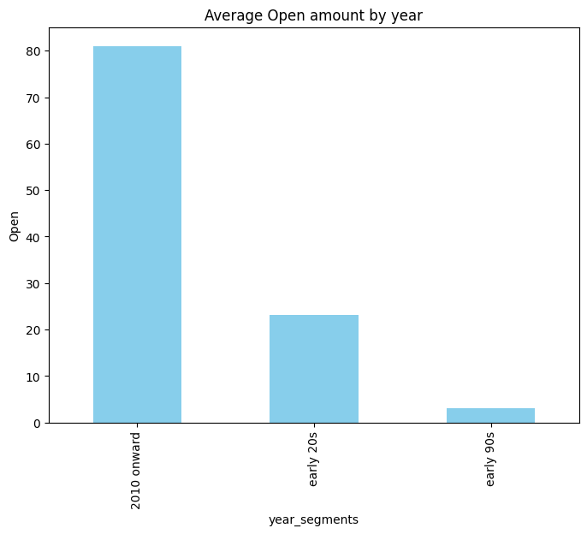

The value for **2010 onward** is substantially higher than both the **early 20s** and the **early 90s**.There is a clear upward trend in the values from the **early 90s** to **2010 onward**.

#### Conclusion

The analysis reveals a marked increase in values associated with the year segment **2010 onward**, in contrast to the **early 90s** and **early 20s**

### Stock Price Segmentation Over Time

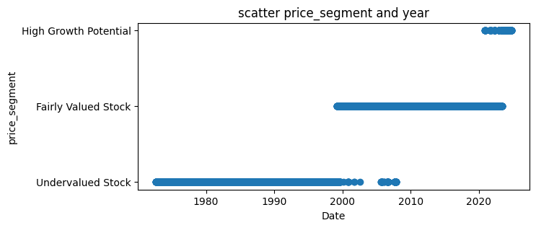

This scatter plot displays the categorization of stock prices over time, divided into three segments: "Undervalued Stock," "Fairly Valued Stock," and "High Growth Potential." Observing this plot, we can see that in earlier years, most stocks were classified as "Undervalued," with a shift towards "Fairly Valued" and "High Growth Potential" in recent years. This progression reflects changes in stock valuation trends over decades, indicating market growth and evolving investor perceptions.

### Average Open amount by year_segments.

The graph shows the average open amount for different time periods. The open amount was highest in the 2010s, followed by the early 2000s, and was the lowest in the early 1990s.

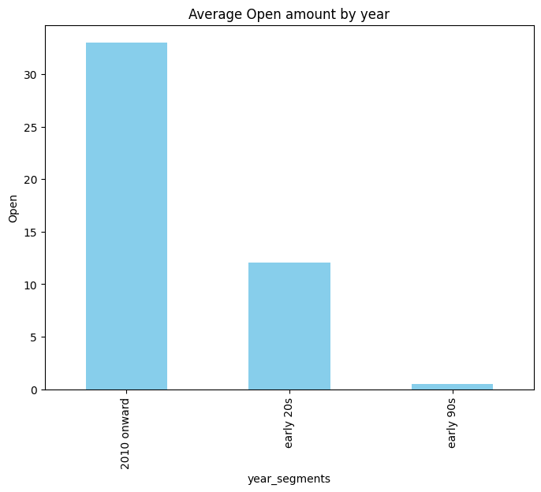

### Price Segment Counts

This bar chart presents the distribution of stocks across three price segments: Undervalued Stock, Fairly Valued Stock, and High Growth Potential

The majority of stocks in the dataset fall into the "Undervalued Stock" category. This suggests that a significant portion of the market is perceived as undervalued.

Economic conditions, interest rates, and overall market trends can influence the perception of stock valuations. A period of economic uncertainty or declining interest rates might lead to more stocks being perceived as undervalued.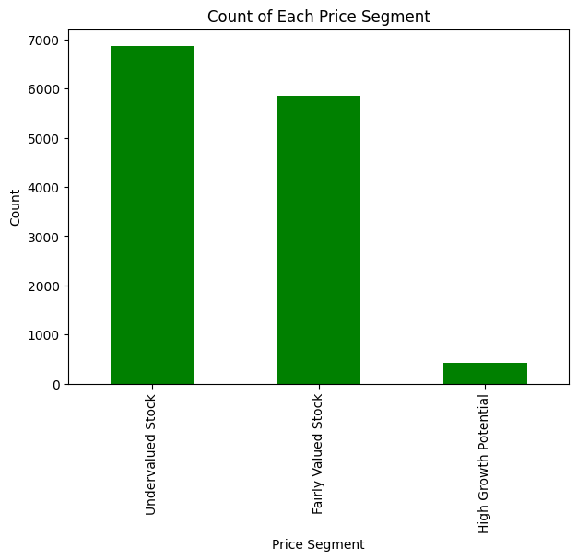

From the provided plots, we can draw the following conclusions:

## Analysis of Trading Volume Over Time

The provided line chart depicts the trading volume over a span of several decades. The chart illustrates fluctuations in trading activity over time.

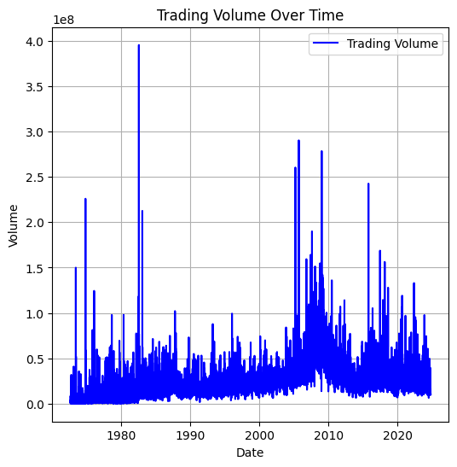

Overall, there appears to be an upward trend in trading volume, particularly in recent years. This suggests increasing market participation and activity.These peaks might correspond to specific events, such as economic announcements, market crises, or technological advancements.

**From the provided plots, we can draw the following conclusions:**

1. **Increase in Average Open Price:** Over the past three decades, there has been a significant increase in the average open price of stocks. This trend is likely driven by economic growth, corporate profitability, and inflationary pressures.
2. **Impact of Dot-Com Bubble:** The early 2000s witnessed a dip in average open prices due to the dot-com bubble burst. This highlights the impact of market sentiment and economic events on stock prices.
3. **Dominance of Undervalued Stocks:** A significant portion of the market is perceived as undervalued, which could indicate a bearish sentiment among investors or potential opportunities for value investors.
4. **Limited High Growth Potential Stocks:** Stocks with high growth potential are relatively scarce, suggesting that such opportunities may be less frequent.

**Overall, the analysis suggests that the stock market has experienced significant growth over the long term, but also faces periods of volatility and uncertainty.** Investors should adopt a long-term perspective, diversify their portfolios, and conduct thorough research to make informed investment decisions.

THANK YOU